ASSIGNMENT FOUR
GLOBOCOM CASE STUDY


Based on the case study, Globocom has a historical reference of being able to make big changes. One such reference would be the upgrade to Oracle’s platform to capturing and analyzing more than 1 billion call-data records per day. But bringing better customer service in the world of technology may be a hinderance in the continent of Africa. Currently, Africa has approximately 1.216 billion people (Demographics of Africa, n.d.). These billions of people aren’t the spear-wielding, lion taming savages with nose rings that we in the West are use to seeing in our movies and television shows. But, realistically, these people aren’t the same as the highly advanced fictional Wakandans from Marvel Comics ‘Black Panther (Roach, n.d.).’ Our brothers and sisters from mother Africa could somehow be seen somewhere in the middle of poverty and almost on their way out. They just need a hand after being looted for thousands of years. Companies like Globocom could be seen as a follower. They would follow other investors if they knew it was safer.
One such potential investor that could illuminate the road of Africa’s technological investment potential is the nation of China. ‘The 21st century will most likely belong to China as the Chinese Century. Chinese investments and contracts in sub-Saharan Africa total $299 billion from 2005 to 2018, according to the China Investment Global Tracker, and in 2018, Chinese president Xi Jinping vowed to invest a further $60 billion into African nations.’ (Brooks, 2019). The data points needed to be referenced for improving network performance are leapfrogging, demographics, adaptability, and culture.
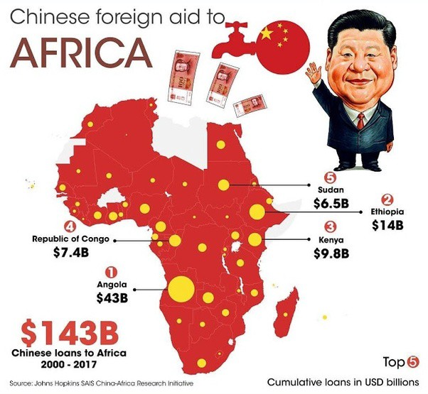
‘In the near future, African nations and peoples will be able to leverage and scale their own discoveries as technology infrastructure becomes cheaper, rather than racing for innovation in the first place’ (Brooks, 2019). ‘Their growing populations along with their immense geographic size will command our attention in positive, sustainable pathways well into the 22nd century. The population of the African continent will double to 4.2 billion by 2100, ensuring that soon two out of every five people on Earth will be African’ (Brooks, 2019). African migrants sent back a record-breaking $37.8 billion in cash to sub-Saharan Africa in 2017, and this amount will likely reach a high of $39.6 billion in 2019 (Brooks, 2019). Currently, Africa’s internet traffic has to go through expensive satellite linkage, thus making the cost of internet access unaffordable by most of the population. But with the large investments of Chinese banks, companies like Globocom will be sure to follow (Internet In Africa, n.d.)
.

References
Demographics of Africa, n.d. In Wikipedia. https://en.wikipedia.org/wiki/Demographics_of_Africa
Brooks, L. 21 Feb 2019. “The 21st Centuy Belongs To China – But The 22nd Will Be Africas.” Retrieved from: https://qz.com/1550626/chinas-investment-will-allow-africa-to-lead-the-22nd-century/#:~:text=The%2021st%20century%20will%20most,China%20as%20the%20Chinese%20Century.&text=Chinese%20investments%20and%20contracts%20in,%2460%20billion%20into%20African%20nations.
Internet in Africa, n.d. In Wikipedia. https://en.wikipedia.org/wiki/Internet_in_Africa
Roach, D. n.d. “Black Panther.” Retrieved from: https://www.britannica.com/topic/Black-Panther-comic-book-character

